CREATE DATABASE employee_db;
USE employee_db;

CREATE TABLE employee(
EmpId INT PRIMARY KEY,
EmpName VARCHAR(50),
Department VARCHAR(50),
Salary DECIMAL(10,2)
);

INSERT INTO Employee VALUES
(101,'Rahul', 'IT',45000),
(102,'Priya', 'HR',52000),
(103,'Amit', 'Finance',60000),
(104,'Sneha',' IT',48000),
(105,'John', 'HR',55000);

TCL Practical
1.Increase Rahul’s salary by 5000.do not commit immediately. verify the result
START TRANSACTION;
UPDATE EMPLOYEE SET Salary=Salary+5000 WHERE EmpName =’Rahul’;
ROLLBACK;
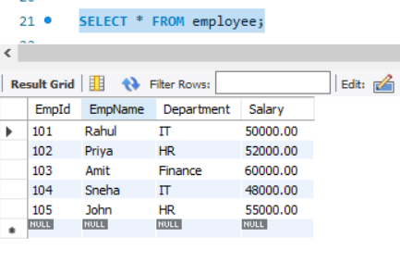
Rollback the transaction.what is rahul salary?
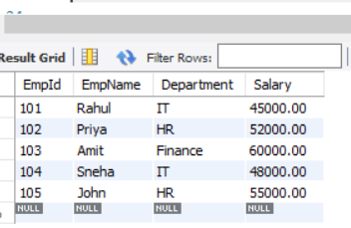
Rahul’s Salary-> Rs.45000

2.Increase Every employee ‘s salary by 10%. Commit the transaction. verify result
START TRANSACTION;
UPDATE EMPLOYEE SET Salary = Salary *1.10;
COMMIT;
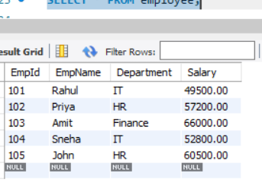

3.Incrrease Rahul’s salary by 3000. Create SAVEPOINT sp1.Increase Priya’s salary by 5000.Rollback to sp1.Which employee’s salary is rolled back?
START TRANSACTION;
UPDATE EMPLOYEE SET Salary = Salary + 3000 WHERE EmpName ='Rahul';
SAVEPOINT Sp1;
UPDATE EMPLOYEE SET Salary = Salary + 5000 WHERE EmpName= 'Priya';
ROLLBACK TO Sp1;
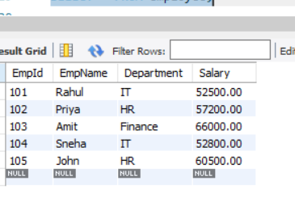
- Priya’s salary is rollback
4. DELETE HR employees. Rollback. how many HR employees remain.
START TRANSACTION;
DELETE FROM EMPLOYEE WHERE Department ='HR';
ROLLBACK;
SELECT COUNT(*) FROM employee WHERE Department='HR';

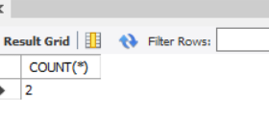
5. DELETE Finance employee. Commit. Then Rollback. Will the finance employees return? Explain
START TRANSACTION;
DELETE FROM EMPLOYEE WHERE Department ='Finance';
COMMIT;
ROLLBACK;
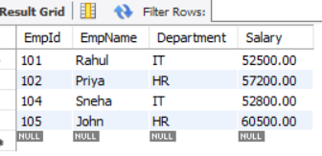
->NO, After COMMIT, ROLLBACK caanot restore the deleted Finance employee.

DCL
1.Query to GRANT SELECT ON employee to student1.
GRANT SELECT ON employee_db.employee TO 'student1';

2.Query to GRANT INSERT on Employee to student1.
GRANT INSERT ON employee_db.employee TO 'student1';

3.Query to GRANT UPDATE on Employee to Student1.
GRANT UPDATE ON employee_db.employee TO 'student1';

4.Query to REVOKE INSERT FOROM student1.
REVOKE INSERT ON employee_db.employee FROM 'student1';

5. Query to REVOKE ALL permission from student1.
REVOKE ALL PRIVILEGES ON employee_db.employee FROM 'student1';

Scenario Based
- A cashier accidentally updates 500 customer records before commit which TCL command be used.
- ROLLBACK;

- Salary changes are verified and should become permanent which command should be used
- COMMIT;

- Undo only the last set of changes without affecting earlier updates which command should be used
- ROLLBACK TO SAVEPOINT savepoint_name;

- A new employees should only view employees records which DCL commands will you used.
GRANT-> GRANT VIEW ON employee TO’ newemployee’;

- A user should no longer have permission to delete records which DCL command will be used
REVOKE -> REVOKE DELETE ON employee FROM’ newemployee’’;

OUTPUT PREDICTION
- START TRANSACTION;
UPDATE employee set salary = salary +5000 WHERE EmpId = 101;
ROLLBACK;
SELECT Salary FROM Employee WHERE EmpId=101;


Question: WILL THE Updated Or original salary displayed?
- Original salary is displayed

- START TRANSACTION;
UPDATE employee set salary = salary +5000 WHERE EmpId = 101;
COMMIT;
ROLLBACK;

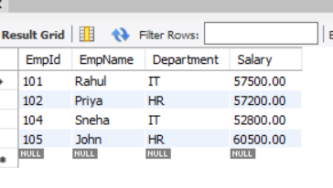
Question: Is the salary restored? Why?
- No, the salary changes permanently saved. So ROLLBACK cannot restore the original salary.

- START TRANSACTION;
UPDATE employee set salary = salary +1000 WHERE EmpId = 101;
SAVEPOINT A;
UPDATE employee set salary = salary +2000 WHERE EmpId = 102;
ROLLBACK TO A;
COMMIT;

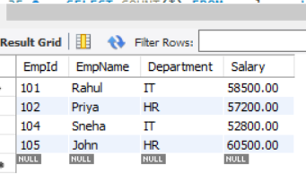
Question: Which employee receives the salary increment?
- Rahul receives increment

FINAL QUESTIONS
1.Increase all IT salaries by 15%
START TRANSACTION;
UPDATE EMPLOYEE SET Salary = Salary *1.15 WHERE Department ='IT';

2.Create SAVEPOINT
SAVEPOINT Sp1;

3.Icrease all HR salaries by 2,000
UPDATE EMPLOYEE SET Salary = Salary + 2000 WHERE Department ='HR';

4.Rollback only the HR update.
ROLLBACK TO SAVEPOINT Sp1;
5.Commit remaining changes
COMMIT;
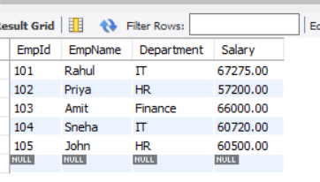
6.GRANT SELECT and UPDATE to student1.
GRANT UPDATE, SELECT ON employee_db.employee TO studen1;

7.Revoke only UPDATE from student1.
REVOKE UPDATE ON employee_db.employee FROM student1.

